Q1.
C: SELECT c.* FROM customers c WHERE c.registration_date >= SYSDATE - 30
AND EXISTS (SELECT 1 FROM orders o WHERE o.customer_id = c.customer_id)

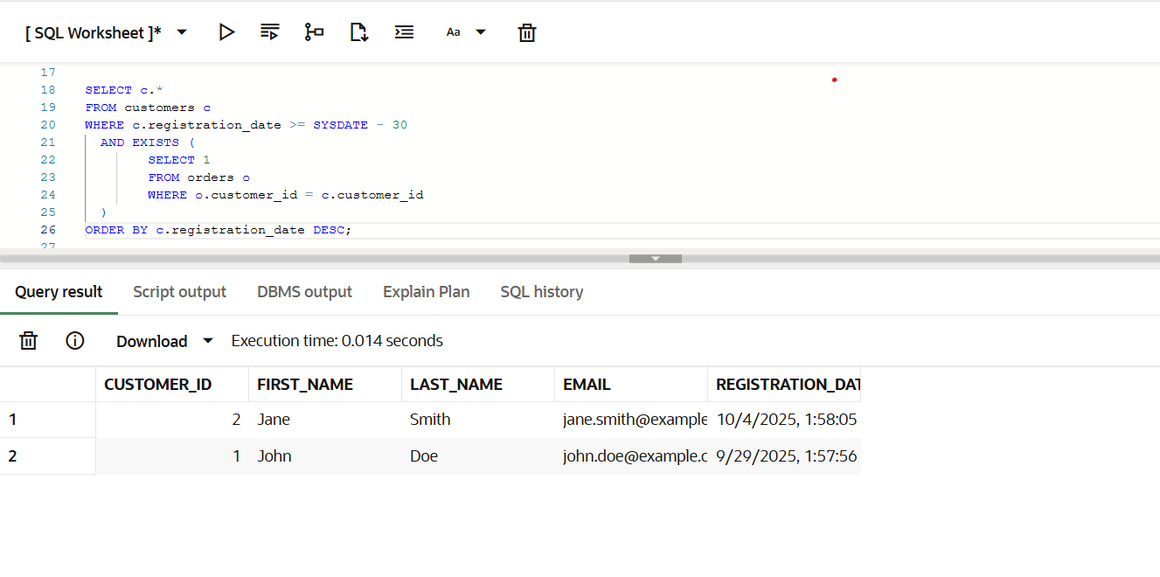

A: customers with multiple orders would appear multiple times.

B: uses DISTINCT to remove duplicates but can be less efficient than EXISTS.

C: The WHERE c.registration_date >= SYSDATE - 30 filters customers registered in the last 30 days. EXISTS(...) checks that at least one matching order exists for that customer and returns each customer only once. This is generally more efficient than a plain JOIN + DISTINCT because EXISTS can stop at the first matching order

D: customers with multiple orders would appear multiple times.

Q2.
A: CREATE INDEX idx_email ON users (email);
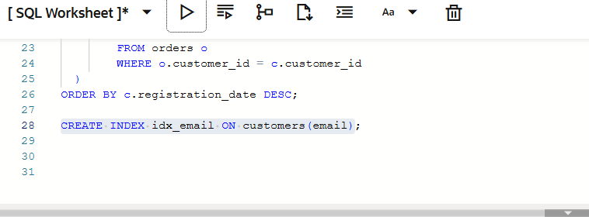

A: That's the standard SQL statement to create a non-unique index on the email column so queries that filter or join on email run faster.

B: is MySQL-specific (ALTER TABLE ... ADD INDEX) — it works in MySQL but is less portable.

C: would make the index unique (only use if emails must be unique).

D: is invalid SQL.

Q3.
B: CREATE TABLE customers (id INT, name VARCHAR(50), email VARCHAR(100))
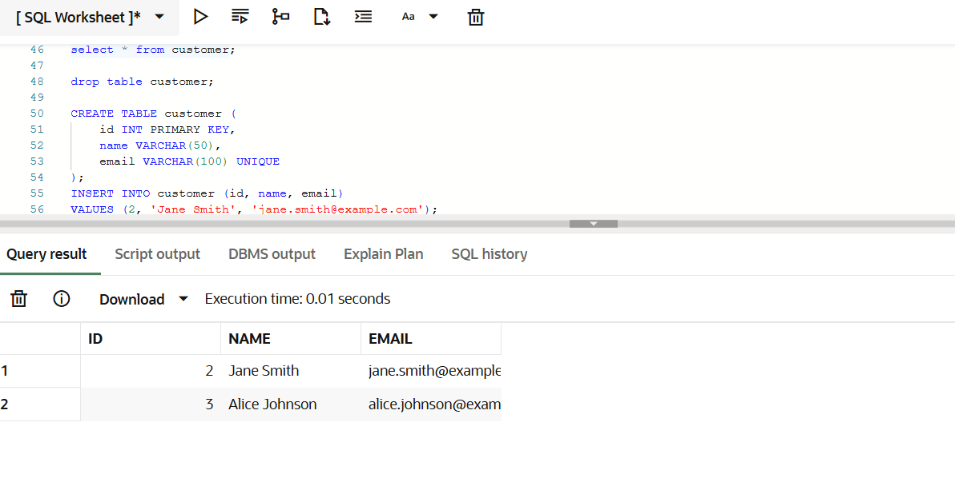A: Sets name as the primary key.Problem: Multiple customers can have the same name, so primary key must be unique, making this design invalid.

B: id → primary key (unique identifier for each customer).
email → unique, ensures no duplicate emails.
name → just a normal column, since multiple customers may have the same name.
This is the standard design for a customer table.

C: No primary key. No uniqueness on email.

D:PRIMARY KEY (id, email) → composite key is unnecessary; id alone is enough.

Q4.
C: SELECT b.* FROM books b WHERE NOT EXISTS (SELECT 1 FROM loans l WHERE l.book_id =
b.book_id);

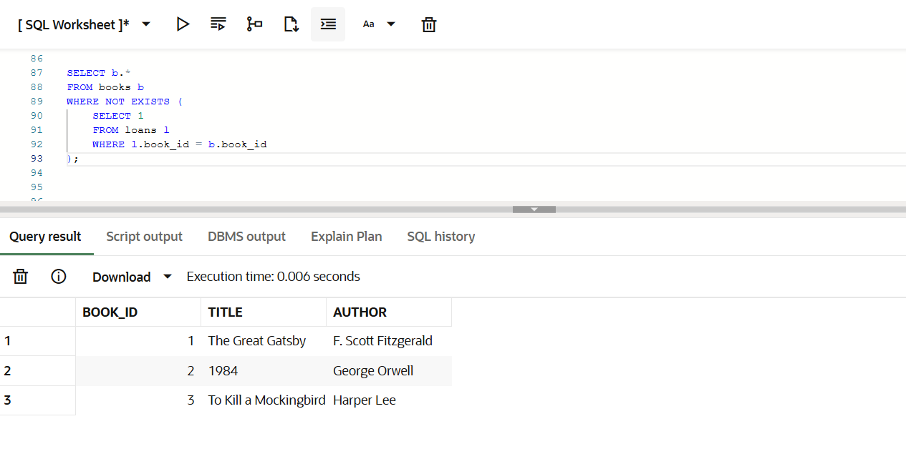
A: Uses LEFT JOIN, very common and readable.But not better than C.

B: Risky if loans.book_id contains NULL.
C: NOT EXISTS checks for the absence of a matching loan for each book. Handles NULLs safely. Standard approach in Oracle.
D: Works, uses MINUS, less common.

Q5.
A. SELECT customer_id, SUM(total_amount) AS total_spent FROM orders WHERE order_date >=
ADD_MONTHS(SYSDATE, -12) GROUP BY customer_id ORDER BY total_spent DESC FETCH
FIRST 5 ROWS ONLY;
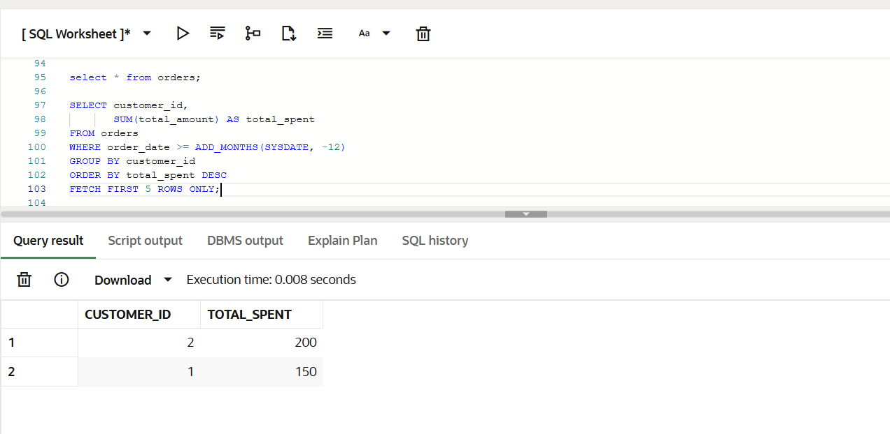
A:· ADD_MONTHS(SYSDATE, -12) → last 12 months
SUM(total_amount) → total spending per customer
GROUP BY customer_id → aggregate by customer
ORDER BY total_spent DESC → highest spender first
FETCH FIRST 5 ROWS ONLY → returns top 5 rows
Modern Oracle 12c+ syntax, efficient and correct.

B: LIMIT 5 is MySQL/PostgreSQL syntax, not valid in Oracle.

C: Will result in syntax error.

D: Invalid SQL syntax in Oracle

Q6.
B: SELECT * FROM dba_hist_sqlstat ORDER BY elapsed_time_total DESC
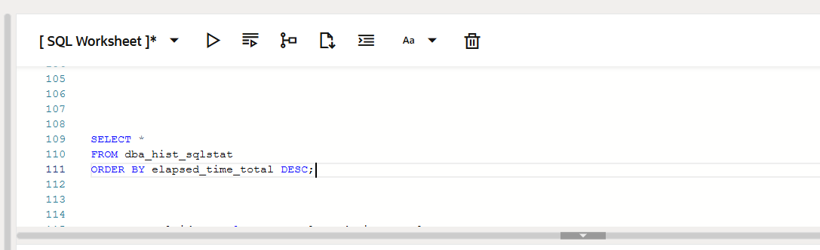
A:Shows current SQL and CPU, but not historical.
B: Historical SQL stats, sort by total elapsed time → best for resource-heavy queries
C: shows most executed queries, not resource-intensive ones.
D: Shows table metadata, like number of rows.

Q7.
C. CREATE OR REPLACE VIEW category_sales AS SELECT c.name, SUM(s.amount) AS total_sales
FROM categories c JOIN products p ON c.category_id = p.category_id JOIN sales s ON p.product_id
= s.product_id WHERE s.sale_date >= ADD_MONTHS(SYSDATE, -1) GROUP BY c.name;
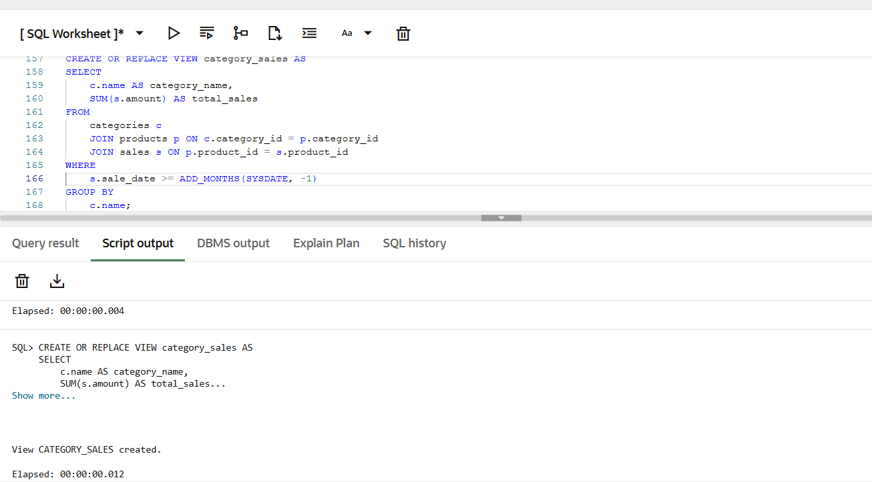
A: Correct syntax but does NOT replace existing view if it exists

B: Works, uses old-style comma joins

C: Modern syntax + can replace existing view safely → recommended
D: may lead to confusion or errors if column types don’t match.

Q8.
A. CREATE INDEX idx_orders ON orders(status, order_date, total_amount)
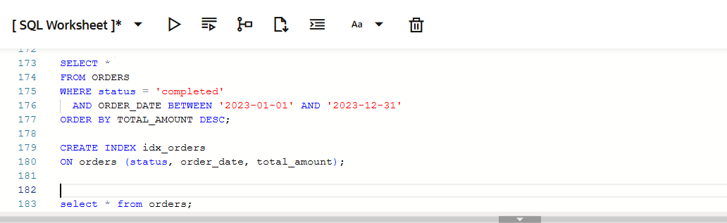
A: status, order_date → used in WHERE clause → filter fast.
total_amount → used in ORDER BY → reduces sort cost.
Composite index matches query order → fastest execution for filtering + sorting.

B: Leading column not in WHERE → inefficient filter

C: Filters status, helps ORDER BY, but misses order_date filter

D: Filters date + status, but ORDER BY still needs sorting

